1. INTRODUCTION

  - ABOUT THE PROJECT
In library, books maintenance through manually is a very tedious process. The problem arises in book reservation management by member because the books should be issued with more priority for earlier booked members. In addition, the reminder should be sent both for book return and reserved book collection. In addition, the current book stock details are to be known in advance so that reservation process becomes easier. During maintaining all these information for all departments, books increase the clerical work more.

At present, all the transactions are maintained through excel. This may result in more work for librarian since they are handling more book records. The work is more in maintaining all information, preparing issued list, returned list and stock maintenance in addition with reservation management.

There is no application with this feature to maintain the transactions with management centrally and work load in distributed fashion. So, this project helps to handle the activities through this application.

The software used to solve the problem and develop the application is Microsoft Visual Studio .Net 2005 and MS-SQL Server 2000.

1.2. SYSTEM SPECIFICATION

1.2.1 HARDWARE SPECIFICATION
This section gives the details and specification of the hardware on which the system is expected to work.

Processor : Pentium IV 1.7 GHz
Hard Disk Capacity : 80 GB
RAM : 1 GB SD
Monitor : 15^{inch} Color
Keyboard : 102 keys
Mouse : Optical Mouse

1.2.2 SOFTWARE SPECIFICATION
This section gives the details of the software that are used for the development.

Environment : Visual Studio 2005.
Front-End : Visual Basic. Net
Back-End : MS-SQL SERVER 2000.
Operating System : Windows XP SP2
2. SYSTEM STUDY

2.1 EXISTING SYSTEM

All the information about the book issue, book return and the reservation report were written and maintained by excel. On demand performance is very slow. Updating and retrieval of information is slow. The existing system is done through Microsoft Excel. The college’s library maintains all the book issue and reservation activities in Excel workbooks so the report generation is tedious. The existing system having lot of drawbacks which are listed below,

2.1.1DRAWBACKS

The existing system has following disadvantages,
- Report generation is tedious.
- More time has to be spent for detailed analysis.
- Book stock along with reservation details cannot be consolidated quickly.
- Book not returned reports can not be generated quickly.
2.2 PROPOSED SYSTEM

The proposed system is required to manage all students books issues, alert to remind the book return and reservation need to be efficiently prepared. The proposed system is computerized system. The proposed approach is managing all the transactions through the application. The ‘sms’ sending activity assists in easy book return and reservation management so that stock management is easy.

2.2.1 FEATURES

The proposed system has following advantages,
- Book issue and return records can be consolidated quickly.
- Detailed reports can be taken immediately with less input.
- Reservation reports for each ISBN Book Number can be taken.
- Helps to manage stock easily.

3. SYSTEM DESIGN AND DEVELOPMENT

3.1 FILE DESIGN

- Design input - Design inputs are typically the initial requirements that describe the GUI controls to be produced.

- Design output - Design outputs are the results of the design and engineering efforts. These are normally the final specifications for the device. Including the design process and the in-coming, in-process and finished device inspection, measurement or test methods and criteria. The outputs are normally documented in models, drawings, engineering analysis and other documents. The output needs to be directly traceable to the input requirements. Design verification and validation should demonstrate that the final output specifications conform to the input requirements and meet user needs and intended uses.

- Design review - The design review is a formal review of the GUI device design by representatives of each design function participating in the design efforts as well as other interested parties (e.g. marketing, sales, manufacturing engineering, etc.). The design review must be documented in the DHF and include review date, participants, design version/revision reviewed and review results.

- Design verification - Design verification is the process that confirms that the design output conforms to the design input. Design verification should demonstrate that the specifications are the correct specifications for the design. Design verification must be documented in the DHF and include the verification date, participants, design version/revision verified, verification method and verification results.
- Design validation - Design validation is the process in which the device design is validated using initial/low volume production processes. The purpose for the design validation is to confirm that the design functions according to design inputs when produced using normal production processes rather than prototype processes. The design validation must be documented in the DHF.

- Design transfer - Design transfer is the process in which the device design is translated into production, distribution, and installation specifications.

- Design changes - Design changes is the process in which the design changes are identified and documented. Also known as engineering change or enterprise change.

- Design history file - The DHF is a formal document that is prepared for each GUI device. The DHF can be either a collection of the actual documents generated in the product development (PD) process or an index of documents and their storage location.

3.2 INPUT DESIGN

Input design is the process of converting user-originated inputs to a computer understandable format. Input design is one of the most expensive phases of the operation of computerized system and is often the major problem of a system. A large number of problems with a system can usually be tracked backs to fault input design and method. Every moment of input design should be analyzed and designed with utmost care.

The design of the input should be made the input as the over to the numerous networks in the reliable area that should be passed as the installation in the remote network.. It has the following constraints in the input database.

- All the files from the disk should be acquired by data.
- It is suitable to more available data clearance and made available.
- The menu of design should be understandable and it is in the right format.

The system takes input from the users, processes it and produces an output. Input design is link that ties the information system into the world of its users. The system should be user-friendly to gain appropriate information to the user. The decisions made during the input design are process in the project.

The project gives the low time consumption to make the sensitive application made simple. When applying the project it provides the low man-power attrition with the reasonable output. The amount of fund that the company can spend into the research and development of the system is limited. The expenditures must be justified. Thus the developed system as well within the budget and this was achieved because most of the technologies used are freely available. Only the customized products had to be purchased.

- To provide cost effective method of input
- To achieve the highest possible level of accuracy
- To ensure that the input is understand by the user
The various forms used to implement this project concept are
- Book module
  - Add Books
- Member module
  - Add member
- Transaction module
  - Book Issue
  - Book Return
  - Book Reservation
ADD BOOKS
In this form, the book details can be added. The details such as bar code number, book name, author, edition, available books and publications are keyed in as input. The available book details can be automatically calculated. The details are saved in the books table.

ADD MEMBER
In this form, the details such as member id, member name, designation, mobile number, address and email id can be given as input. And the details are saved in the member table.

BOOK ISSUE
In this form, the book issue details can be given as input. The details such as bar code number, book name, author, edition, available books and publications, issue date and return date can be added. The return date is automatically calculated from the issue date. Then the details are stored in the issue table.

BOOK RETURN
In this form, the book return details can be given as input. The details such as bar code number, book name, author, edition, available books and publications, issue date and return date can be added. If it exceeds the return date means, it automatically sends SMS to the appropriate member. At the same time the alert message can be displayed to the admin through the notify icon. Then the details are stored in the return table.
BOOK RESERVATION
In this form, the book reservation details can be given as input. The details such as bar code number, book name, author, edition, available books and publications, issue date and return date can be added. The books can be reserved only if the available books are empty. Then if a member needs at that time means, the books can be reserved and SMS can be sending to the member, when book is available in library. And the reserved books can be provided to the member according to priority wise. Then the details are stored in the reservation table. “Record Saved” message will be displayed. Then find operation can be performed. If record matches, then it displayed in the form, otherwise it shows the alert message “Record not match”. Then delete operation can be performed
3.3 OUTPUT DESIGN

Output design generally refers to the results and information that are generated by the system for many end-users; it should be understandable with the enhanced format. The Output of the software is used to make the remote installation of the new software in the system and, it is awake the immediate alert to the system that should be enhanced it as the input to the system. Output is the main reason for developing the system and the basis on which they evaluate the usefulness of the application.

Computer output is the most important direct source of information to the user output design deals with form design efficient output design should improve the interfacing with user. The term output applies to any information produced by an information system in terms of displayed. When analyst design system output, they Identify the specific output that is needed to meet the requirements of end user..

When designing output, system analysis accomplishes more things like, to determine what applications, websites or documents whether blocked or allowed. Allowing should be in various options. The output is designed in such a way that it is attractive, convenient and informative. Forms are designed in VB.NET with various features, which make the console output more pleasing.

As the outputs are the most important sources of information to the users, better design should improve the system’s relationships with user and also will help in decision-making. Form design elaborates the way output is presented and the layout available for capturing information.

The following output forms are used to implement this project.
- Books
- Members
- Book Issue/Returns
- Book Reservation
- SMS Log
BOOKS REPORT
In this form, the book details report can be viewed.

MEMBERS REPORT
In this form, the member details report can be viewed.

BOOK ISSUE/RETURNS
In this form, the book issue and return details report can be viewed.

BOOK RESERVATION
In this form, the book reservation details report can be viewed. And also view the details such as whether the SMS is send or not.

SMS LOG
In this form, the SMS log details report can be viewed. The details such as time, date, so on details can be viewed.

3.4 DATABASE DESIGN
The most important consideration in designing the database is, how information will be used. The main objectives of designing a database are:

DATA INTEGRATION
In a database, information from several files are coordinated, accessed and operated upon as through it is in a single file. Logically, the information are centralized, physically, the data may be located on different devices, connected through data communication facilities.

DATA INTEGRITY
Data integrity means storing all data in one place only and how each application to access it. This approach results in more consistent information, one update being sufficient to achieve a new record status for all applications. This leads to less data redundancy; data items need not be duplicated; a reduction in the direct access storage requirement.

DATA INDEPENDENCE
Data independence is the insulation of application programs from changing aspects of physical data organization. This objective seeks to allow changes in the content and organization of physical data without reprogramming of applications and to allow modifications of application programs without reorganizing the physical data.

The tables needed for each module were designed and the specification of each and every column based on the records is provided and details collected during record specification of the system study.
The major objectives for maintaining such a database are:
- The database must reduce redundancy
- Enforce standards
- Share data and maintain integrity
- The data must be independent and consistent
- We must to able to apply security restrictions

3.5 SYSTEM DEVELOPMENT
The process is the stage of the project when the theoretical design is turned out into a working system. Thus it can be considered to be the most critical stage in achieving a successful new system and in giving the user, confidence that the new system will work and be effective.

This stage involves careful planning, investigation of the existing system and it’s constraints on implementation, designing of methods to achieve changeover and evaluation of changeover methods.

The process of converting a new system design into operation. It is the phase that focuses on user training, site preparation and file conversion for installing a candidate system. The important factor that should be considered here is that the conversion should not disrupt the functioning of the organization.

3.5.1 DESCRIPTION OF MODULES
The project contains following modules
1. Book
2. Member
3. Transaction
4. Reports
BOOK
The book module is used to store barcode number, author name, book name, edition publication, book count and book availability. The barcode number is selected when the book issue, return and reservation is done. The stock information is adjusted when book issue and return

MEMBER
The member module is used to member id, member name, and designation, mobile, address and date of birth. The member name will be displayed automatically when the book issue, return and reservation, the member id is to be selected.

TRANSACTION
A) BOOK ISSUE
The book issue module is used to store book issue details. When the book issue, the stock available books barcode number can be selected; the member id and issue date are given. Only member with no book in hand are displayed. The stock value is reduced accordingly.

B) BOOK RETURN
The book return module is used to store book return details. When the book return, the issued books barcode number can be selected; the member id and return date are given. Only member with book in hand are displayed. The stock value is increased accordingly. When the book is in reservation list, the first reserved member is alerted with an ‘SMS’ to come and collect the book.

C) BOOK RESERVATION
The book reservation module is used to store book reservation details. During book reservation, the books barcode number with no stock is displayed; the book not in hand Member id is selected. The member will receive alert when the book is returned in future.

REPORTS
In this module, the books and member list is displayed. In addition, book issues, return and reservation details are viewed. The ‘SMS’ sent log also displayed in this module

4. SYSTEM TESTING AND IMPLEMENTATION

4.1 SYSTEM TESTING

After the source code has been completed, documented as related data structures. Completed the project has to undergo testing and validation where there is subtitle and definite attempt to get errors. The project developer treads lightly, designing and execution test that will demonstrates that the program works rather than uncovering errors, unfortunately errors will be present and if the project developer doesn’t find them, the user will find out.

The project developer is always responsible for testing the individual units i.e. modules of the program. In many cases developer also conducts integration testing i.e. the testing step that leads to the construction of the complete program structure.

This project has undergone the following testing procedures to ensure its correctness.
- Unit testing
2. User Acceptance Testing

4.1.1 UNIT TESTING

In unit testing, we have to test the programs making up the system. For this reason, Unit testing sometimes called as Program testing. The software units in a system are the modules and routines that are assembled and integrated to perform a specific function, Unit testing first on the modules independently of one another, to locate errors. This enables, to detect errors in coding and logic that are contained with the module alone. The testing was carried out during programming stage itself.

4.1.2 INTEGRATION TESTING

Integration testing is a systematic technique for constructing the program structure. While at the same time conducting tests to uncover errors associated with interfacing. The objective is to take unit tested modules and build a program structure that has been dictated by design.

In this integration testing its done using the main module and based on the type of integration testing the subordinate tables and other criteria along with their path, is replaced one at a time with actual modules.

4.1.3 VALIDATION TESTING

It is said that validation is successful when the software functions in a systematic manner that can be reasonably accepted by the customers. This type of testing is very important because it is the only way to check whether the requirements given by user have been completely fulfilled.

4.2 SYSTEM IMPLEMENTATION

When the initial design was done for the system, the client was consulted for the acceptance of the design so that further proceedings of the system development can be carried on. After the development of the system a demonstration was given to them about the working of the system. The aim of the system illustration was to identify any malfunction of the system.

After the management of the system was approved the system implemented in the concern, initially the system was run parallel with existing manual system. The system has been tested with live data and has proved to be error free and user friendly.

Implementation is the process of converting a new or revised system design into an operational one when the initial design was done by the system; a demonstration was given to the end user about the working system. This process is uses to verify and identify any logical mess working of the system by feeding various combinations of test data. After the approval of the system by both end user and management the system was implemented.
System implementation is made up of many activities. The six major activities are as follows.

Coding
Coding is the process of whereby the physical design specifications created by the analysis team turned into working computer code by the programming team.

Testing
Once the coding process is begin and proceed in parallel, as each program module can be tested.

Installation
Installation is the process during which the current system is replaced by the new system. This includes conversion of existing data, software, and documentation and work procedures to those consistent with the new system.
Documentation
It is result from the installation process, user guides provides the information of how the use the system and its flow.

Training and support

Training plan is a strategy for training user so they quickly learn to the new system. The development of the training plan probably began earlier in the project. The best-suited application package to develop the system is Visual Basic .NET under windows XP’ environment.
5. CONCLUSION

The project “SMS BASED LIBRARY MANAGEMENT SYSTEM” which reduce the librarian work through easy record reference and reducing the clerical work. This system provides the two types of SMS alerts to the customer one is due date of the book and the another one is availability of the book.

The SMS option is used to alert the member to remind the returning date of the books to the member.The book reservation which also gives information through the SMS regarding the books those who are registered previously.

The application eliminates the manual communication difficulties currently faced by administrator and librarian. It is developed in a user-friendly manner since the application is developed using .Net.

The application is very fast and any transaction can be processed across the network. Error messages are given at each level of input of individual stages. The application works well for all department students’ records management. Any node with .Net framework installed can execute the application.

6. SCOPE FOR FUTURE ENHANCEMENT

The application become useful if the below enhancements are made in future.

- If the application is designed as web service, it can be integrated in many web sites.
- The books can be reserved, or viewed through online.
- User Name and Password can be provided for individual users to access their account

The application is developed such that above said enhancements can be integrated with current modules.
7. BIBLIOGRAPHY
BOOK REFERENCE

- Alistair Mc Monnies, “Object-oriented programming in Visual Basic. Alistair Mc Monnies, “Object-oriented programming in Visual Basic. NET”, Pearson Education, and BARCODE: 81-297-0649-0, First Indian Reprint 2004.
- Jittery R.Shapiro, “The Complete Reference Visual Basic .NET” Edition 2002, Tata McGraw-Hill, Publishing Company Limited, New Delhi.
- Roger s. Pressman “Software Engineering” Tata McGraw-Hill, Publishing Company Limited
- Francesco Balena, “Programming Microsoft Visual Basic 2005: The Language”, Microsoft Press.
- David I. Schneider, “Introduction to Programming with Visual Basic .Net 2005”, Prentice Hall.

WEB REFERENCES

- http://vbdotnetheaven.com
- http://www.codeproject.com
- http://msdn.microsoft.com
- http://www.roseindia.net
- http://www.learnershome.com
- http://www.homeandlearn.com
APPENDICES

A. DATAFLOW DIAGRAM

LEVEL 0:

SMS
Log
Admin
Master and Transaction
Views and
Reports

LEVEL 1:

View

SMS Log
Member Details
Book Details
Book
Member
Member
Book
Data
Data
Record Saved
Record Saved
Retrieving Records
Retrieving Records
Retrieving Data

LEVEL 2:

Check for Reservation
Members
Check for Condition
Storage and Retrieve Transaction Details
View
Book Reservation
Book Issue
Book Return
Book Return
Book Reservation
Book Issue
Book Reservation Details
Book Issue / Return Details
SMS Log Details
Send SMS
Data
Data
Data
If Already Issued
Send SMS
Record Saved
Record Saved
Record Saved
Retrieved Records

LEVEL 3:

View
Report
SMS Log List
Reservation List
Book List
Book issue / Return List
Book Reservation
Member
Book
Book Issue
Book Return
Retrieving Records

B.TABLE STRUCTURE
Table Name: Admin
Purpose : This table contains username and password for login.
Primary key: UserName
FIELD NAME | TYPE | SIZE | DESCRIPTION
UserName | varchar | 15 | Primary Key
Password | varchar | 15 | Password

Table Name: Books
Purpose : This table is used to store the book details.
Primary key: Barcode Number
FIELD NAME | TYPE | SIZE | DESCRIPTION
BarcodeNumber | varchar | 20 | Primary Key
AuthorName | varchar | 50 | Author name of book
BookName | varchar | 100 | Name of the book
Edition | varchar | 20 | Print edition of book
Publications | varchar | 50 | Publication of book
BookCount | int | 4 | Stock Quantity
Available | int | 4 | Stock Quantity

Table Name: Issues
Purpose : Issue table is used to store the book issued details.
Primary key: SNo
Foreign Key: BarcodeNumber

FIELD NAME | TYPE | SIZE | DESCRIPTION
Sno | INT | 4 | Primary Key
BarcodeNumber | varchar | 20 | Foreign Key
BookName | varchar | 100 | Name of the book
Edition | varchar | 15 | Print edition of book
MemberID | varchar | 12 | Id of Member
MemberName | varchar | 30 | Name of the member
IssueDate | date/time | 8 | Date of book issue
ReturnDate | date/time | 8 | Date of book return
Returned | bit | 1 | Check the book return or not

Table Name: SMSLog
Purpose : This table is used to store the ‘sms’ outgoing details.
Primary key: SNo
Foreign Key: RegisterNo, SMSType
FIELD NAME | TYPE | SIZE | DESCRIPTION
Sno | int | 4 | Primary Key
EntryTime | date/time | 8 | Date/Time of Entry
RegisterNo | varchar | 12 | Foreign Key
SMSType | int | 4 | Foreign Key

Table Name: Reservation
Purpose : This table is used to store the book reservation details
Primary key: SNo
Foreign Key: BarcodeNumber
FIELD NAME | TYPE | SIZE | DESCRIPTION
Sno | int | 4 | Primary Key
BarcodeNumber | varchar | 20 | Foreign Key
AuthorName | varchar | 20 | Name of the author
BookName | varchar | 100 | Name of the book
Edition | varchar | 15 | Print edition of book
MemberID | varchar | 12 | Id of Member
MemberName | varchar | 30 | Name of the member
ReservationDate | date/time | 8 | Date of Reservation
SMSSent | bit | 1 | Check for SMS sent or not

Table Name: SMSSettings
Purpose : This table is used to store the ‘sms’ message details.
Primary key: SMSTypeID
FIELD NAME | TYPE | SIZE | DESCRIPTION
SMSTypeID | int | 4 | Primary Key
SMSMessage | varchar | 255 | Message details

Table Name: Member
Purpose : This table is used to store the member details.
Primary key: MemberId
FIELD NAME | TYPE | SIZE | DESCRIPTION
MemberId | varchar | 12 | PRIMARY KEY
MemberName | varchar | 30 | Member name
Designation | varchar | 20 | Members designation
Mobile | varchar | 12 | Mobile number of members
Address | varchar | 50 | Member address details
DOB | datetime | 8 | Date of birth for member

APPENDICES
A.SAMPLE INPUT FORMS

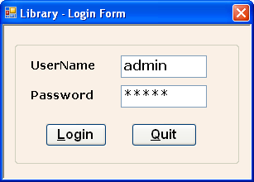

FIG.NO.A.1 LOGIN FORM

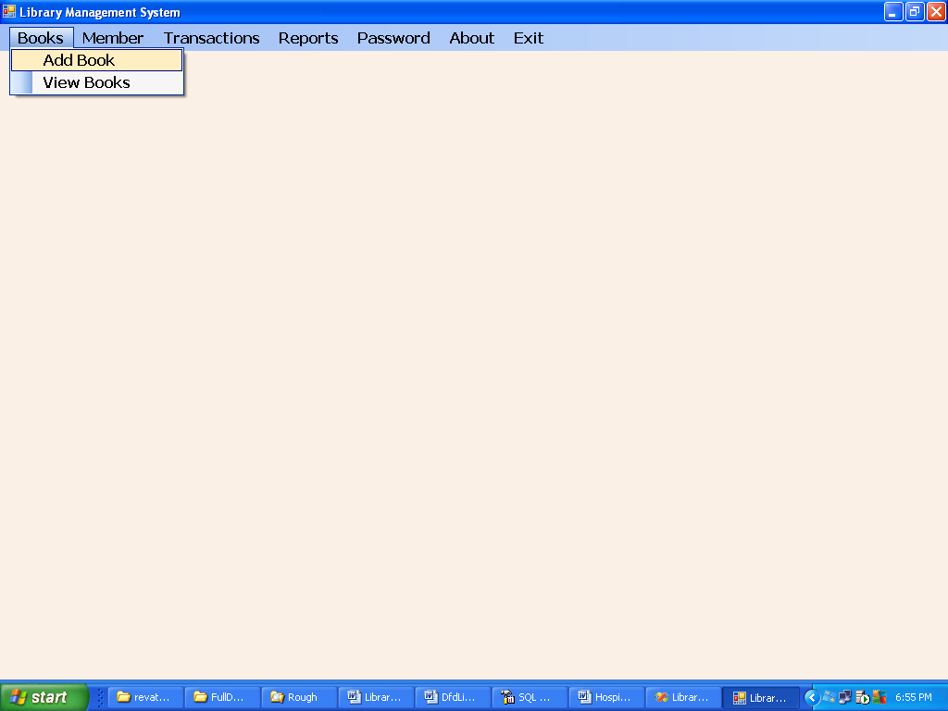

FIG.NO.A.2 BOOK MENU FORM

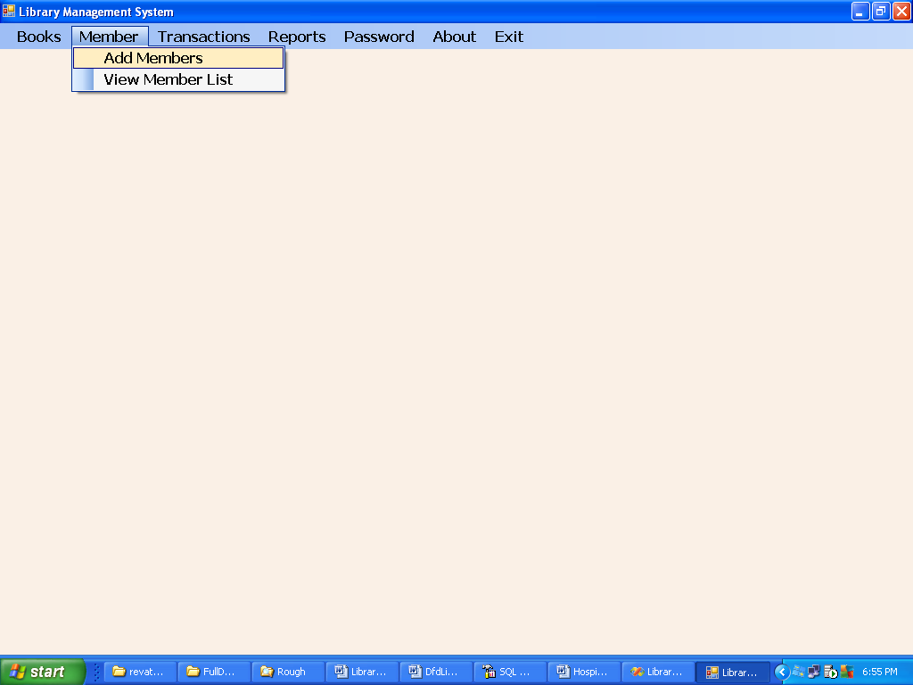

FIG.NO.A.3 MEMBER MENU FORM

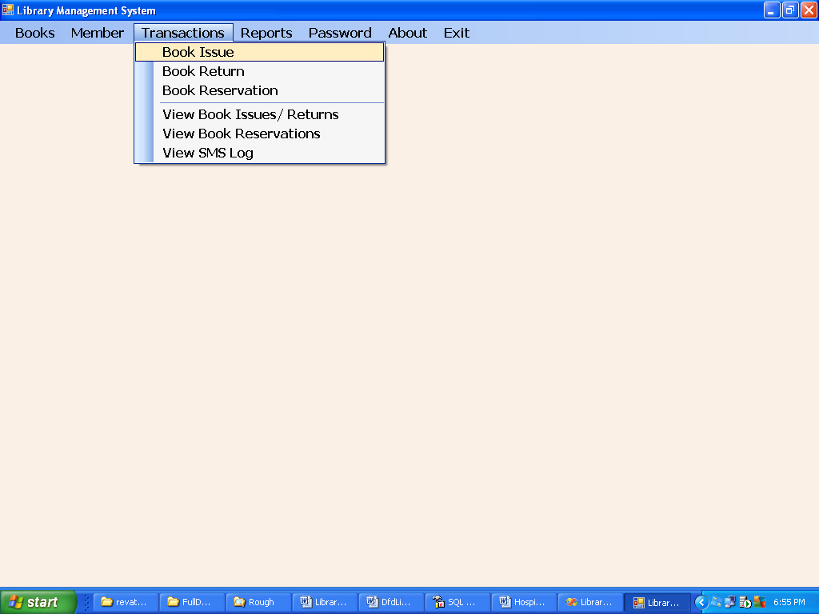

FIG.NO.A.4 TRANSACTION MENU FORM

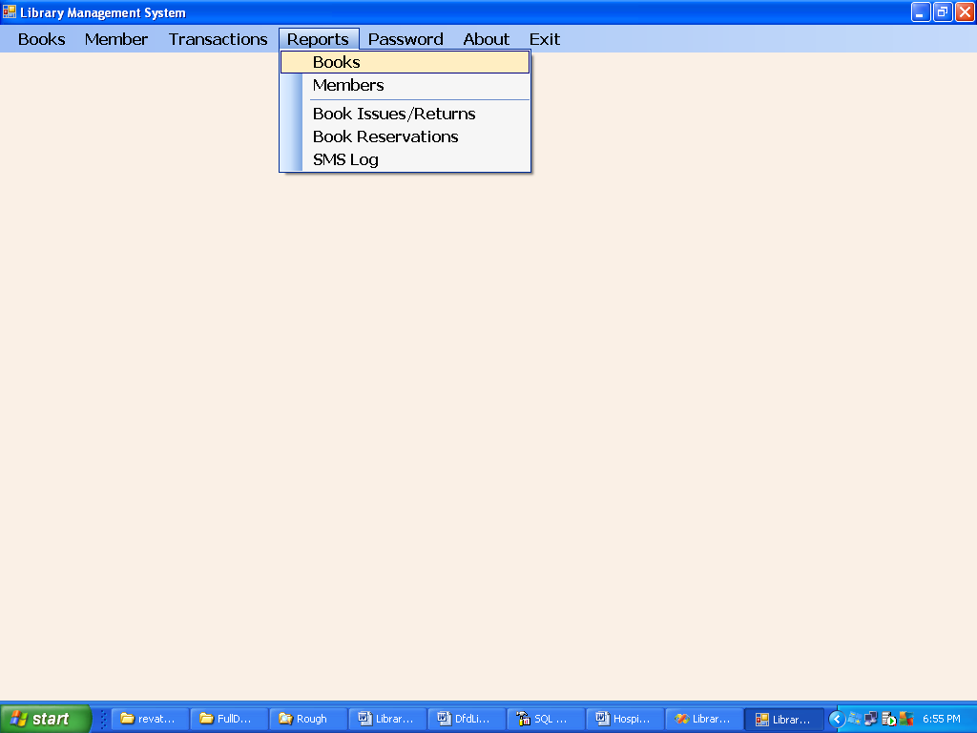

FIG.NO.A.5 REPORTS MENU FORM

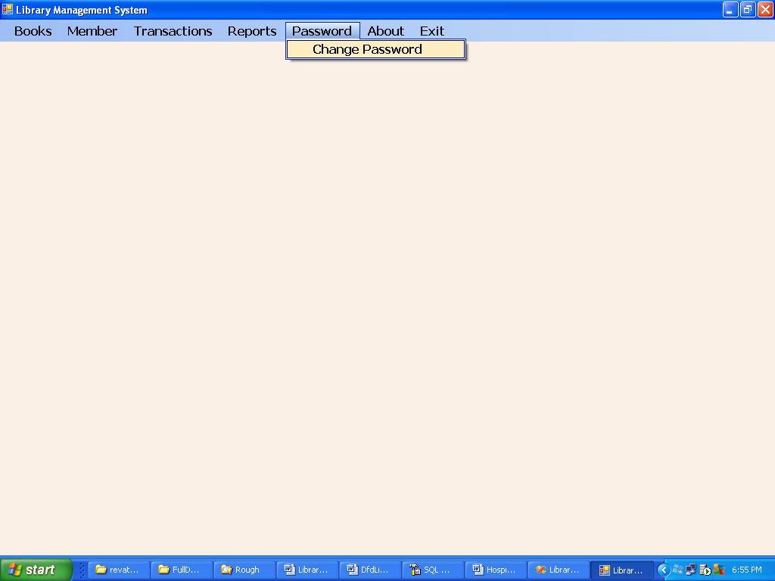

FIG.NO.A.6 PASSWORD MENU FORM

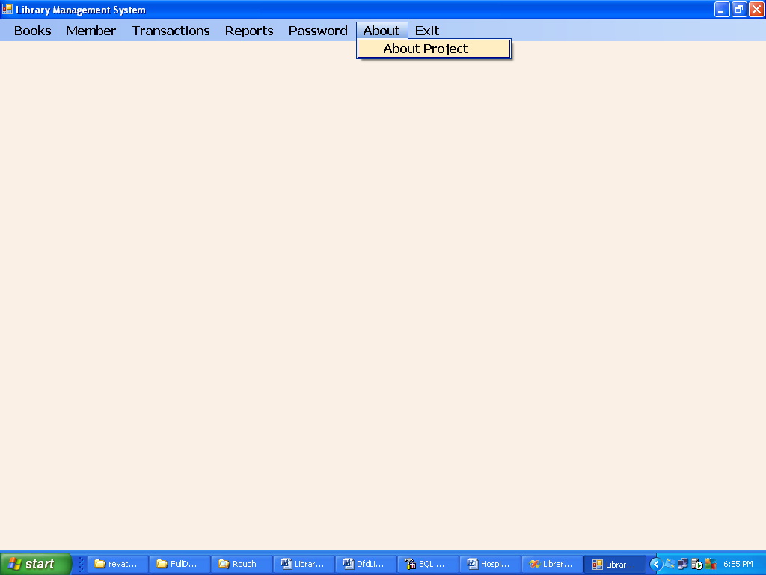

FIG.NO.A.7 ABOUT MENU FORM

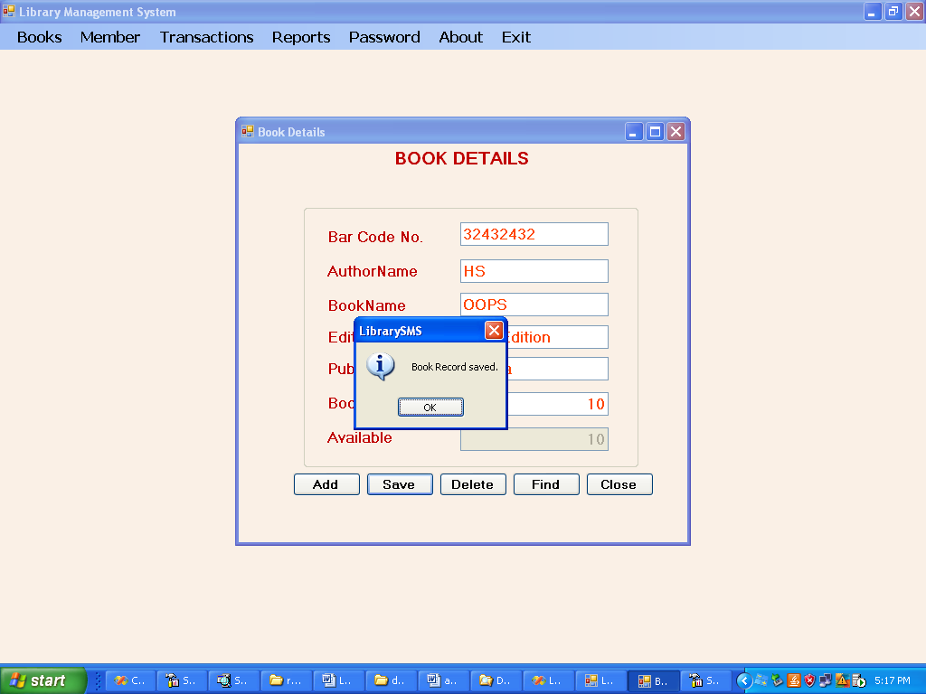

FIG.NO.A.8 BOOK DETAILS FORM

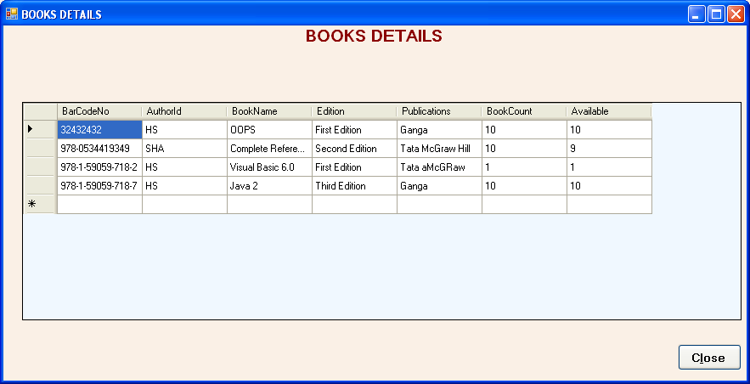

FIG.NO.A.9 VIEW BOOK DETAILS FORM

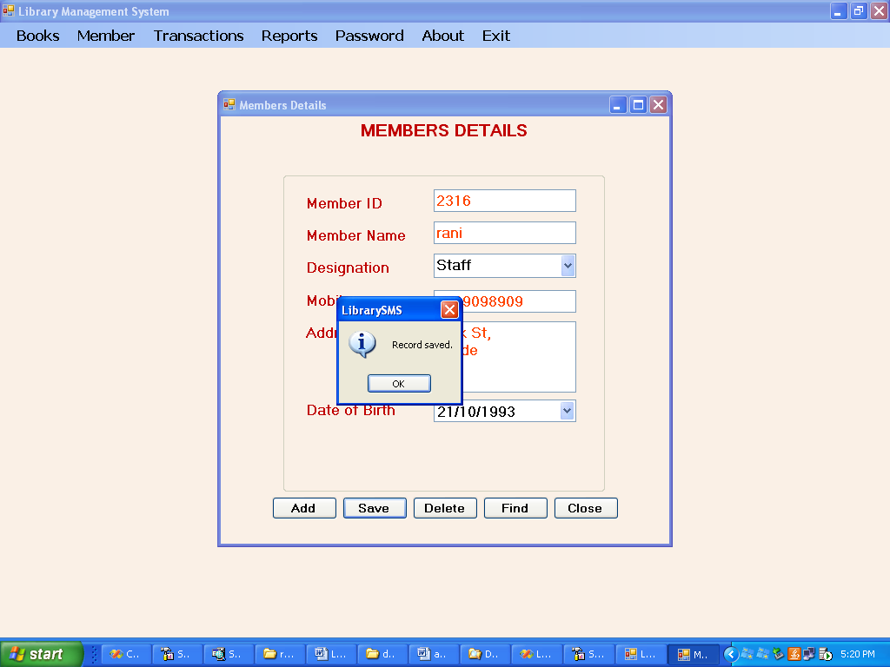

FIG.NO.A.10 MEMBER DETAILS FORM

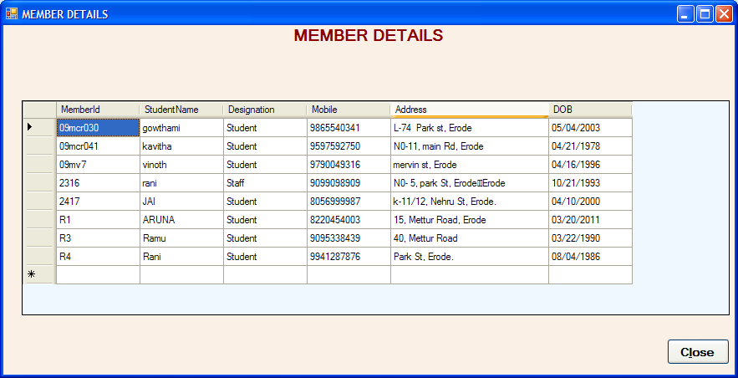
MemberName

FIG.NO.A.11 VIEW MEMBER DETAILS FORM

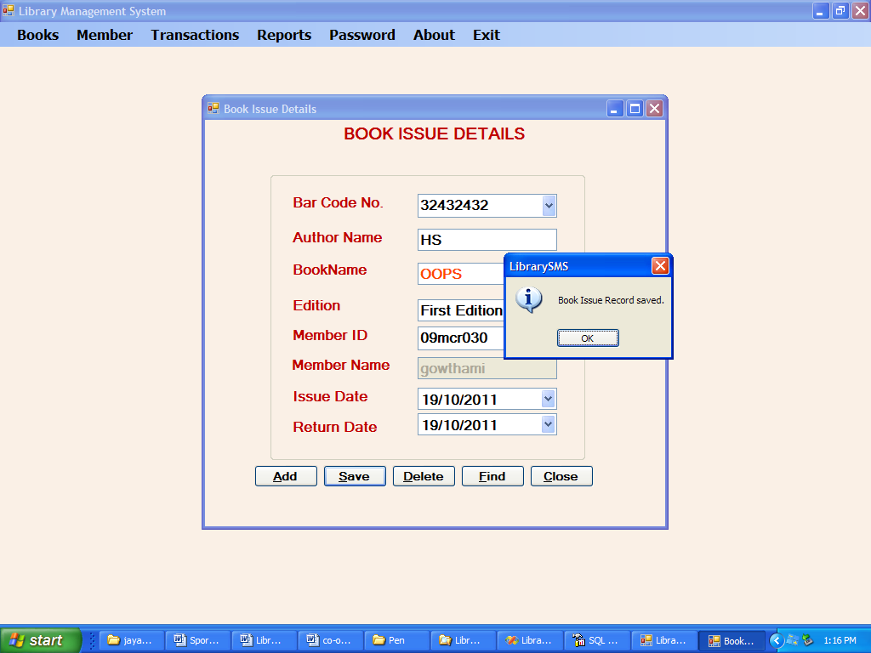

FIG.NO.A.12 BOOK ISSUE DETAILS FORM

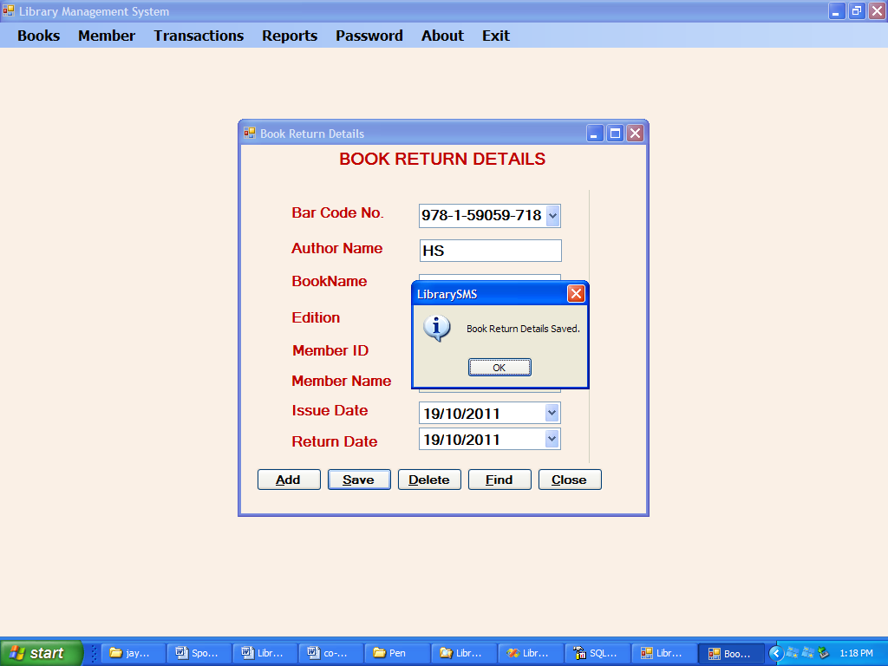

FIG.NO.A.13 BOOK RETURN DETAILS FORM

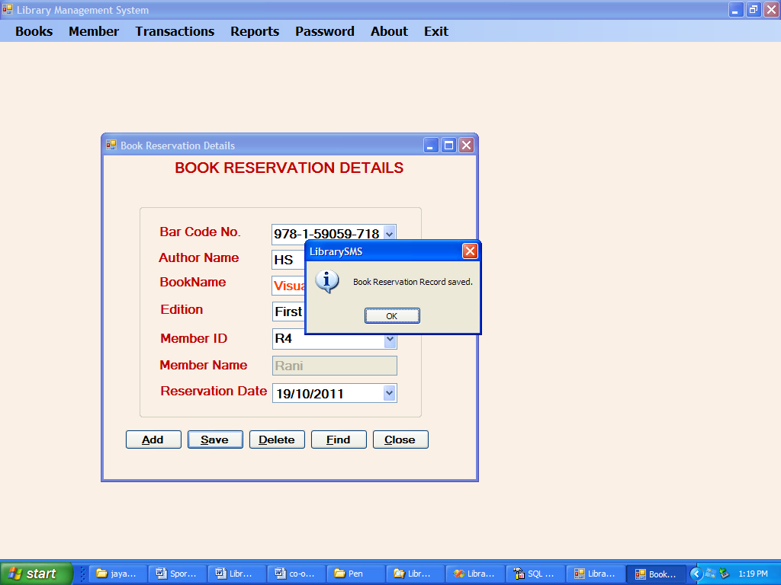

FIG.NO.A.14 BOOK RESERVATION DETAILS FORM

SAMPLE CODE

BOOK

Imports System.Data.SQLClient

Public Class frmBooks

Private Sub frmBooks_FormClosing(ByVal sender As Object, ByVal e As System.Windows.Forms.FormClosingEventArgs) Handles Me.FormClosing
If con.State <> ConnectionState.Closed Then con.Close()

End Sub

Private Sub frmBooks_KeyDown(ByVal sender As Object, ByVal e As System.Windows.Forms.KeyEventArgs) Handles Me.KeyDown
If e.KeyCode = Keys.Return Then
SendKeys.Send("{tab}")
End If
End Sub

Private Sub frmBooks_Load(ByVal sender As System.Object, ByVal e As System.EventArgs) Handles MyBase.Load
If con.State <> ConnectionState.Open Then con.Open()
End Sub
Sub ClearControls()

Dim x As Control
For Each x In GroupBox1.Controls
If TypeOf x Is TextBox Then
x.Text = ""
End If
Next

T1.Focus()
End Sub

Private Sub Button3_Click(ByVal sender As System.Object, ByVal e As System.EventArgs) Handles Button3.Click
Dim saved As Boolean = False
cmd.CommandText = "Select Count(*) From Books where BarCodeNo='" & T1.Text & "'"
If cmd.ExecuteScalar > 0 Then
If MsgBox("ISBN Number already found. Do you want to overwrite?", MsgBoxStyle.YesNo Or MsgBoxStyle.Question) = MsgBoxResult.Yes Then
Dim tran As SQLTransaction = Nothing
Try
tran = con.BeginTransaction
cmd.Transaction = tran
cmd.CommandText = "Delete from Books where BarCodeNo='" & T1.Text & "'"
cmd.ExecuteNonQuery()
cmd.CommandText = "Insert into Books values('" & T1.Text & "','" & TextBox1.Text & "','" & T3.Text & "','" & txtBookEdition.Text & "','" & T4.Text & "','" & T5.Text & "','" & T6.Text & "')"
cmd.ExecuteNonQuery()
tran.Commit()
saved = True

Catch ex As Exception
MsgBox(ex.Message, MsgBoxStyle.Critical)
saved = False
tran.Rollback()
End Try
End If
Else

cmd.CommandText = "Insert into Books values('" & T1.Text & "','" & TextBox1.Text & "','" & T3.Text & "','" & txtBookEdition.Text & "','" & T4.Text & "','" & T5.Text & "','" & T6.Text & "')"
cmd.ExecuteNonQuery()
saved = True

End If
If saved Then
MsgBox("Book Record saved.", MsgBoxStyle.Information)
Else
MsgBox("Book Record not saved.", MsgBoxStyle.Information)
End If
End Sub

Private Sub Button2_Click(ByVal sender As System.Object, ByVal e As System.EventArgs) Handles Button2.Click

ClearControls()

End Sub

Private Sub Button4_Click(ByVal sender As System.Object, ByVal e As System.EventArgs) Handles Button4.Click
Dim acode As String
acode = InputBox("Enter ISBN Number")
cmd.CommandText = "Delete from Books where BarCodeNo='" & acode & "'"
If cmd.ExecuteNonQuery > 0 Then
MsgBox("Book Record deleted.", MsgBoxStyle.Information)
ClearControls()
Else
MsgBox("Book Record not deleted.", MsgBoxStyle.Information)
End If
End Sub

Private Sub Button5_Click(ByVal sender As System.Object, ByVal e As System.EventArgs) Handles Button5.Click
Dim acode As String
acode = InputBox("Enter BarCode Number")
cmd.CommandText = "Select * from Books where BarCodeNo='" & acode & "'"

Dim r As SQLDataReader = cmd.ExecuteReader

If r.Read Then
If IsDBNull(r(0)) Then
T1.Text = ""
Else
T1.Text = r(0)
End If
If IsDBNull(r(1)) Then
TextBox1.Text = ""
Else
TextBox1.Text = r(1)
End If

If IsDBNull(r(2)) Then
T3.Text = ""
Else
T3.Text = r(2)
End If
If IsDBNull(r(3)) Then
txtBookEdition.Text = r(3)
End If
If IsDBNull(r(4)) Then
T4.Text = ""
Else
T4.Text = r(4)
End If
If IsDBNull(r(5)) Then
T5.Text = ""
Else
T5.Text = r(5)
End If
If IsDBNull(r(6)) Then
T6.Text = ""
Else
T6.Text = r(6)
End If
Else
MsgBox("Book Record not found.", MsgBoxStyle.Information)
End If
r.Close()
End Sub

Private Sub Button1_Click(ByVal sender As System.Object, ByVal e As System.EventArgs) Handles Button1.Click
Me.Close()

End Sub

Private Sub T5_TextChanged(ByVal sender As System.Object, ByVal e As System.EventArgs) Handles T5.TextChanged
T6.Text = T5.Text

End Sub
End Class

MEMBER

Imports System.Data.SQLClient

Public Class frmMember

Private Sub frmStudents_FormClosing(ByVal sender As Object, ByVal e As System.Windows.Forms.FormClosingEventArgs) Handles Me.FormClosing
If con.State <> ConnectionState.Closed Then con.Close()

End Sub

Private Sub frmStudents_KeyDown(ByVal sender As Object, ByVal e As System.Windows.Forms.KeyEventArgs) Handles Me.KeyDown
If e.KeyCode = Keys.Return Then
SendKeys.Send("{tab}")
End If
End Sub

Private Sub _Load(ByVal sender As System.Object, ByVal e As System.EventArgs) Handles MyBase.Load
If con.State <> ConnectionState.Open Then con.Open()
'Dim R As SQLDataReader
'cmd.CommandText = "Select AuthorId From Authors"

'R = cmd.ExecuteReader
'While R.Read
' ComboBox1.Items.Add(R(0))
'End While
'R.Close()

End Sub
Sub ClearControls()

Dim x As Control
For Each x In GroupBox1.Controls
If TypeOf x Is TextBox Then
x.Text = ""
End If
Next

T1.Focus()
End Sub

Private Sub Button3_Click(ByVal sender As System.Object, ByVal e As System.EventArgs) Handles Button3.Click
Dim saved As Boolean = False
cmd.CommandText = "Select Count(*) From Students where MemberID='" & T1.Text & "'"
If cmd.ExecuteScalar > 0 Then
If MsgBox("Register No. already found. Do you want to overwrite?", MsgBoxStyle.YesNo Or MsgBoxStyle.Question) = MsgBoxResult.Yes Then
Dim tran As SQLTransaction = Nothing
Try
tran = con.BeginTransaction
cmd.Transaction = tran
cmd.CommandText = "Delete from Students where MemberID='" & T1.Text & "'"
cmd.ExecuteNonQuery()
cmd.CommandText = "Insert into Students values('" & T1.Text & "','" & TextBox1.Text & "','" & ComboBox1.Text & "','" & T3.Text & "','" & T4.Text & "','" & Format(DateTimePicker1.Value, "dd/MM/yyyy") & "')"
cmd.ExecuteNonQuery()
tran.Commit()
saved = True

Catch ex As Exception
MsgBox(ex.Message, MsgBoxStyle.Critical)
saved = False
tran.Rollback()
End Try
End If
Else

cmd.CommandText = "Insert into Students values('" & T1.Text & "','" & TextBox1.Text & "','" & ComboBox1.Text & "','" & T3.Text & "','" & T4.Text & "','" & Format(DateTimePicker1.Value, "MM/dd/yyyy") & "')"
cmd.ExecuteNonQuery()
saved = True

End If
If saved Then
MsgBox("Record saved.", MsgBoxStyle.Information)
Else
MsgBox("Record not saved.", MsgBoxStyle.Information)
End If
End Sub

Private Sub Button2_Click(ByVal sender As System.Object, ByVal e As System.EventArgs) Handles Button2.Click

ClearControls()

End Sub

Private Sub Button4_Click(ByVal sender As System.Object, ByVal e As System.EventArgs) Handles Button4.Click
Dim acode As String
acode = InputBox("Enter Register No.")
cmd.CommandText = "Delete from Students where MemberID='" & acode & "'"
If cmd.ExecuteNonQuery > 0 Then
MsgBox("Record deleted.", MsgBoxStyle.Information)
ClearControls()
Else
MsgBox("Record not deleted.", MsgBoxStyle.Information)
End If
End Sub

Private Sub Button5_Click(ByVal sender As System.Object, ByVal e As System.EventArgs) Handles Button5.Click
Dim acode As String
acode = InputBox("Enter Member ID")
cmd.CommandText = "Select * from Students where MemberID='" & acode & "'"

Dim r As SQLDataReader = cmd.ExecuteReader

If r.Read Then
If IsDBNull(r(0)) Then
T1.Text = ""
Else
T1.Text = r(0)
End If
If IsDBNull(r(1)) Then
TextBox1.Text = ""
Else
TextBox1.Text = r(1)
End If

If IsDBNull(r(2)) Then
ComboBox1.Text = ""
Else
ComboBox1.Text = r(2)
End If

If IsDBNull(r(3)) Then
T3.Text = ""
Else
T3.Text = r(3)
End If
If IsDBNull(r(4)) Then
T4.Text = ""
Else
T4.Text = r(4)
End If
If IsDBNull(r(5)) Then

Else
DateTimePicker1.Value = r(5)
End If

Else
MsgBox("Record not found.", MsgBoxStyle.Information)
End If
r.Close()
End Sub

Private Sub Button1_Click(ByVal sender As System.Object, ByVal e As System.EventArgs) Handles Button1.Click
Me.Close()

End Sub

End Class

